Kaitlyn Dominguez

Dr. Rivas

Project 2 Final Report

Due May 8, 2017

**Abstract**

This report will discuss my final project for Software Development 1. I decided to create a image editor Java application. This application allows the users to upload a picture and add filters to it through buttons and a menu. Specifically, this report will discuss my decision to create an image filtering application, the systems description, the physical requirements of the application, the literature survey and the user manual of this application.

**Introduction**

For my Software Development 1 Final Project, I decided to design a Java image editor. I’ve always loved taking pictures and have always used Instagram to share my favorite photos with my friends. I personally take a lot of pictures on my cell phone because I always have it on me. But cell phone pictures definitely do not compare to photos taken on a quality camera. To enhance my pictures, I would always use small filters to make my pictures look more professional. I wanted to make a image filtering Java application because it is something I could actually use and was interested in making. This program provides people an easy and effective way to enhance their pictures through a Java application.

**Systems Description**

This application allows users to edit their image using buttons and a menu. The original picture that appears on the application is written in the code but can always be changed. Under the picture, there are six buttons that allows the user to increase and decrease brightness, increase and decrease contrast, negate all the colors, and return back to the original, unfiltered image. The user can also click on the menu which includes other filters. Through the menu, which is at the top left corner of the screen, users can sharpen the picture, blur the picture, and change the picture’s colors. The buttons and the menu give users a variety of basic image filters that can help enhance the quality of the image. As seen in the picture below, the buttons are on the bottom of the screen while the menu is on the top left of the application.

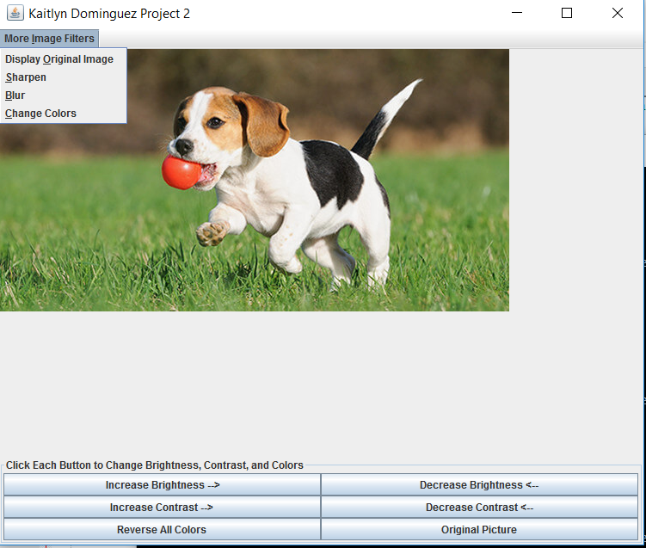

As shown in the UML Diagram below, this application has three main classes with attributes: Project2(), ButtonListener(), and ImagePanel(). These classes have several attributes and methods in them.

Kate’s Project 2 Image Editor

Project2():

filterM: JMenu

imagePanel: ImagePanel

sharpen: myFilter

blur: myFilter

Color: myFilter

ButtonListener():

button: JButton

ImagePanel():

displayPicture: BufferedImage

originalPicture: BufferedImage

Picture: Image

Project2()

WindowEventHandler()

ButtonListener()  
createMenuItem()  
blurredFilter()

imagePanel()

applyFilter()

displayOriginalFilter()

sharpenFilter()

colorFilter()

DisplayPanel()

**Requirements**

This application does not take a lot of physical requirements to run. The program must be downloaded in order to work on the computer. It also has a default image of a dog that comes with the application. This image must also be downloaded with the application if the user would like to edit it or use it to learn about the features on the image editor. The user can change the image but it must be changed in the code which only requires two quick changes. This application will work with .jpg or .png. Other than this minor change, it is not hard to get the application to function correctly. It is fairly easy to apply the filters, through both the buttons and the menu, and it is easy to erase all the applied filters and start over (there is an options for this both in the panel of buttons and the menu). It is not an intensive application for people to use.

**Literature Survey**

In the social-media-obsessed age we live in today, image editors are used by several people to edit the pictures they post online. Instagram, an app that allows people to share their favorite pictures with their friends, has become one of the biggest social media sites in the world. Instagram also provides users filters and editing features to help enhance their images. Most people who post on Instagram use these filters meaning millions of people use Instagram as their primary image filtering application. Along with Instagram, there are also other iOS and Android apps that people use to edit their pictures.

My image editor differs from others primarily that it is a Java application. Most people don’t use a Java image filtering application to edit their pictures but I think there is one huge benefit to using Java this way: you do not need an internet connection to edit pictures. All other image editor applications require wifi or will use data, with a Java application this isn’t necessary. My application also specializes in specific changes used to enhance the image instead of making it unrecognizable. The buttons allow users to have control over the amount of brightness and contrast they want on their pictures. If they want more drastic filters, those are also available to them in the menu. While the image editor industry is highly competitive and on the rise right now, my application does stand out for people who want a different image filtering method than Instagram.

**User Manual**

Once the picture is entered into the code, the application is very easy to use. As explained before, you can edit your image using the buttons on the bottom of the application and through the menu at the top left of the application. There are six buttons on the application with labels explaining what they do. To make the changes, the user just has to click on them. These buttons contain three filters: brightness, contrast, and a color change. The brightness filter has two buttons, one to increase brightness and another to decrease brightness. The contrast filter also has two buttons for the same purpose. The user can click on these buttons as much as they want because each click with increase or decrease the filter. There is only one button for the color change filter which only require one click. Finally, there is a button that allows the user to start over and return back to the original image. The buttons are shown below.

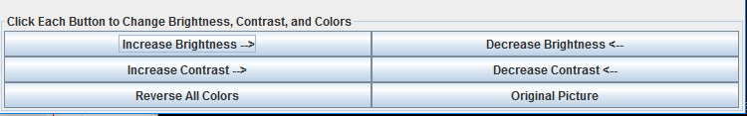

The user can also use the menu to access more image filters. The menu is titled “More Image Filters”. If the user clicks it, it will turn into a drop-down menu. The options listed on the menu are a sharpness filter, a blur filter, and another (different) color change filter. These filters all only require one click which is why they are listed in the menu section instead of the buttons. The menu is shown below.

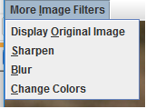

Users can click whichever filters they want whenever they want. There is no specific order between the menu and the buttons.

**Conclusion**

In conclusion, this program is primarily for people who would like to enhance their pictures using a Java application. A Java application allows people to edit their images without internet connection or data usage. My image editor is also easy to use and includes several filters to let users customize their images however they would like. Overall, this application is an easy and effective way to edit images.